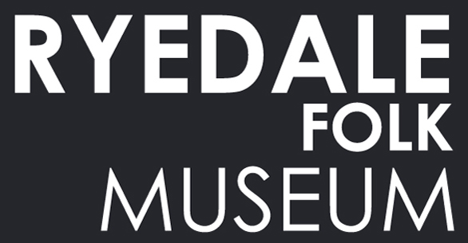

Senior Visitor Services Assistant

Context

Ryedale Folk Museum is located in the heart of the North York Moors National Park. For almost sixty years we’ve conserved some of the area’s most magnificent heritage for current and future generations to enjoy. Our atmospheric buildings and collections, spread over six acres, tell a story about a rural way of life since Iron Age.
The Museum also features a gift shop and art gallery.

The successful candidate will be employed to provide a welcoming experience for visitors through the efficient handling of admissions and shop sales and maintain our excellent standards of customer service. The postholder will undertake work which supports the running of the Museum’s gift shop and basic administrative duties.

If you are interested in an informal conversation about the role please contact
Hannah Highsted, Operations Manager on 01751 417367.

How to apply
1. Complete the application form at www.ryedalefolkmuseum.co.uk/get-involved/
2. Complete the Diversity Monitoring form
3. Send all documents by the closing date to Hannah Highsted at:
hannah@ryedalefolkmuseum.co.uk

or by post or by hand to:

Hannah Highsted
Operations Manager
Ryedale Folk Museum
Hutton le Hole
North Yorkshire
YO62 6UA

Application deadline – midnight, Sunday 2 February
Interviews – to be held week commencing 10 February, on a day convenient to both parties
Applicants invited to interview will be informed by Tuesday 4 February.

Job Title: Senior Visitor Services Assistant Reporting To: Operations Manager

Pay: £13/hour Contract: 10 March until 30 November 2025

Working days
Saturday and Sunday, 2 weekends a month

Working hours:
9.00am – 5.30pm from April to September
9.00am – 4.30pm in March, October and November

Please note: Due to the responsibilities required of the candidate, Ryedale Folk Museum is only inviting applications from persons aged 18 years or older. Due to the site location, candidates must be able to arrange transport to and from the Museum – public transport is not available. A first aid qualification will be required and successful postholders will need to attend an appropriate first aid course shortly after commencing the role (with fees, costs and time paid for by the Museum).

Main Responsibilities

- Ensure that all visitors are greeted with a warm welcome (and goodbye) and receive a consistently high standard of customer service.
- Work with other staff and volunteers, supporting each other with front of house tasks, making sales and operating the point-of-sale systems.
- Be the lead member of staff (alongside another member of staff) at the weekends, dealing with arising and emergency issues.
- Sell admission tickets and provide all visitors will help and clear advice about their visit to the Museum (and the wider North York Moors National Park).
- Set up the point-of-sale system and cash-up each day.
- Maintain a high-standard of presentation throughout the reception, retail and art gallery areas – replenishing and rotating stock (in a timely manner) and cleaning as required.
- Open and close the Museum’s buildings ensuring safety and security measures are met (weekends only) and undertake light cleaning duties of the toilets (weekends only).
- Understand the alarm systems and emergency procedures and assist with or carry out the evacuation of the site in the event of an emergency.
- Feed the animals and be observant about any causes for concern (weekends only).
- Undertake administrative tasks including answering visitor enquiries and data entry.

Other duties

- Preparing retail stock for sale, including pricing items and displaying point of sale and restocking merchandise cupboards.
- Liaise with the Retail Coordinator and/or Director on any matters relating to retail, stock levels or quality issues.
- Attend staff meetings and training.
- Administer first aid (full training will be provided).
- Adhere to the health and safety policy and procedures. Be aware of risks and ensure that these are minimised, including cash handling processes.
- Take pride in your personal presentation, complying with the agreed dress code and wearing any designated uniform or clothing as required.

Personal Specification

 | Essential | Desirable
Education /qualifications
GCSE level, or equivalent, including pass grades in English and Maths. | √
Knowledge and Experience
Experience of working in a retail, visitor attraction or other customer-service role. | √
Cash handling experience. | √
Experience of using stock control systems. |  | √
Experience of working with volunteers. |  | √
Skills and Abilities
Ability to communicate with a diverse range of people in a friendly, effective, and helpful manner, and the ability to consider the needs of visitors with different needs. | √
A general awareness of health and safety and how to spot potential or arising issues. | √
ICT literate including use of email, internet searches and general computer use. | √
Calm and confident when dealing with busy, challenging or difficult and emergency situations. | √
Ability to work on own initiative and recognise when a task needs to be undertaken or completed. | √
Personal Attributes
An empathy for the work of Ryedale Folk Museum and an enthusiasm in communicating the work of the Museum to the general public. | √
A smart and professional appearance at all times. | √
A commitment to equality and diversity | √
Full UK driving license | √
Willingness to work flexibly to achieve role responsibilities | √
Ability to work some weekends and evenings, as the job requires. | √

Due to the Museum’s location, the postholder must be able to arrange transport to and from the Museum to attend work. Public transport is not available.

